**1. Write a program in assembly language to display a two-digit number on the screen. The**

**two-digits number is required to be taken in the program itself.**

**CODE:**

ORG 100h ; Origin for .COM file format

_start:

; Display message "The two-digit number is: "

MOV DX, OFFSET msg_output

MOV AH, 09h

INT 21h

; Hardcoded two-digit number

MOV AL, '4' ; First digit

MOV DL, AL

MOV AH, 02h ; DOS function to display character

INT 21h

MOV AL, '5' ; Second digit

MOV DL, AL

INT 21h

; Move to a new line

MOV DL, 0Dh ; Carriage return

MOV AH, 02h

INT 21h

MOV DL, 0Ah ; Line feed

INT 21h

; Terminate the program

MOV AH, 4Ch

INT 21h

msg_output DB 'The two-digit number is: $'

END

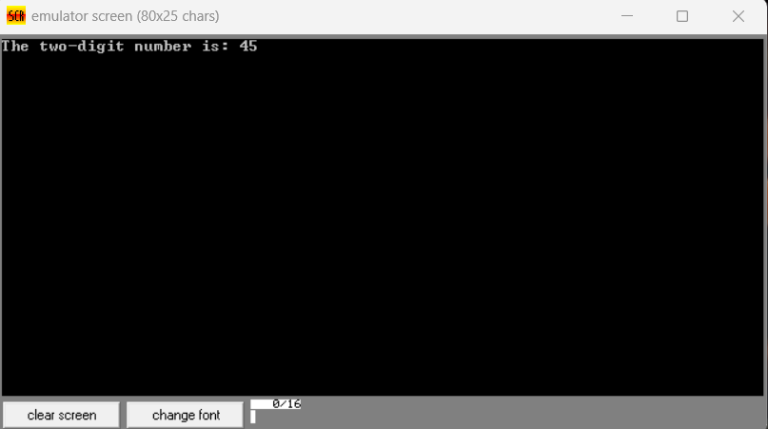

**Practice Set:**

**2. Write an assembly language program to take two single-digit integers from the user and**

**print the result of addition on the screen.**

**CODE:**

**ORG 100h**

**; Prompt for first digit**

**mov ah, 09h ; DOS interrupt to display a string**

**lea dx, msg1 ; Load address of the first message**

**int 21h ; Display the message**

**mov ah, 01h ; DOS interrupt to read a character**

**int 21h ; Read first digit**

**sub al, '0' ; Convert ASCII to integer**

**mov bl, al ; Store first number in BL**

**; Print a new line after input**

**mov ah, 02h**

**mov dl, 0Dh ; Carriage return (CR)**

**int 21h**

**mov dl, 0Ah ; Line feed (LF)**

**int 21h**

**; Prompt for second digit**

**mov ah, 09h ; DOS interrupt to display a string**

**lea dx, msg2 ; Load address of the second message**

**int 21h ; Display the message**

**mov ah, 01h ; DOS interrupt to read a character**

**int 21h ; Read second digit**

**sub al, '0' ; Convert ASCII to integer**

**add bl, al ; Add second number to BL (BL now holds the sum)**

**; Print a new line after input**

**mov ah, 02h**

**mov dl, 0Dh ; Carriage return (CR)**

**int 21h**

**mov dl, 0Ah ; Line feed (LF)**

**int 21h**

**; Check if the sum is greater than 9 (two-digit number)**

**cmp bl, 9**

**jg two_digits ; If sum > 9, jump to handle two-digit result**

**mov ah, 09h ; DOS interrupt to display a string**

**lea dx, msg3 ; Load address of the sum message**

**int 21h ; Display the sum message**

**; Print single-digit sum**

**add bl, '0' ; Convert to ASCII**

**mov dl, bl ; Move sum to DL for printing**

**mov ah, 02h ; DOS interrupt to print a character**

**int 21h ; Print the result**

**jmp done ; Jump to the end of the program**

**two_digits:**

**; Handle two-digit result (sum >= 10)**

**mov ah, 09h ; DOS interrupt to display a string**

**lea dx, msg3 ; Load address of the sum message**

**int 21h ; Display the sum message**

**mov al, bl ; Move sum to AL**

**mov ah, 0**

**mov dl, 10**

**div dl ; AL = quotient (tens), AH = remainder (ones)**

**; Print tens digit**

**add al, '0' ; Convert to ASCII**

**mov dl, al**

**mov bh, ah ; Move tens to DL**

**mov ah, 02h ; DOS interrupt to print a character**

**int 21h ; Print tens digit**

**; Print ones digit**

**mov ah, bh**

**mov al, ah ; Move ones to AL**

**add al, '0' ; Convert to ASCII**

**mov dl, al ; Move ones to DL**

**mov ah, 02h ; DOS interrupt to print a character**

**int 21h ; Print ones digit**

**done:**

**; Exit program**

**mov ah, 4Ch ; DOS interrupt to exit the program**

**int 21h**

**msg1 db 0Dh, 0Ah, 'Enter first digit: $' ; Message for first input, with newline**

**msg2 db 0Dh, 0Ah, 'Enter second digit: $' ; Message for second input, with newline**

**msg3 db 0Dh, 0Ah, 'The sum is: $' ; Message for sum result, with newline**

